Phishing Email Analysis & Awareness Report
Name: Mohdissa Fizza
Date: 24 April 2026
1. Introduction
Phishing is one of the most common and costly cyberattacks faced by businesses today. Attackers use fake emails to trick users into:
- Clicking malicious links
- Downloading infected files
- Sharing passwords or OTPs
Most phishing attacks succeed not because of weak systems, but because users are unaware of how to identify fake emails.
Organizations invest in:
- Phishing email analysis
- Employee awareness programs
- Internal security guidelines
This report analyzes email samples and provides awareness to help users recognize and prevent phishing attacks.
2. Objective
The objective of this report is to:
- Analyze real-world email samples
- Identify phishing indicators
- Classify email risk (Safe / Suspicious / Phishing)
- Explain attacks in simple language
- Provide prevention guidelines for users
3. Tools Used
Email Analysis Tools
- Google Message Header Analyzer
- MX Toolbox Email Header Analyzer
Browser Tools
- URL inspection (checking domain authenticity)
Documentation Tools
- Microsoft Word
Email headers can be analyzed to verify sender authenticity and detect spoofing.
4. Methodology
The following steps were as follows:
- Collected sample emails
- Analyzed sender details and headers
- Checked links and domains
- Identified phishing indicators
- Classified risk level
- Documented findings
- Created awareness guidelines
5. Email Analysis
5.1 Email 1 – Safe Email (Legitimate)
Subject: Your Monthly Statement is Ready
Analysis:
This email is a legitimate notification from ADIB bank. It informs the user without requesting sensitive data.
Phishing Indicators Check:
- Official domain (adib.com / adib.ae)
- Personalized greeting
- No urgency or threats
- No request for credentials
Risk Classification: Safe

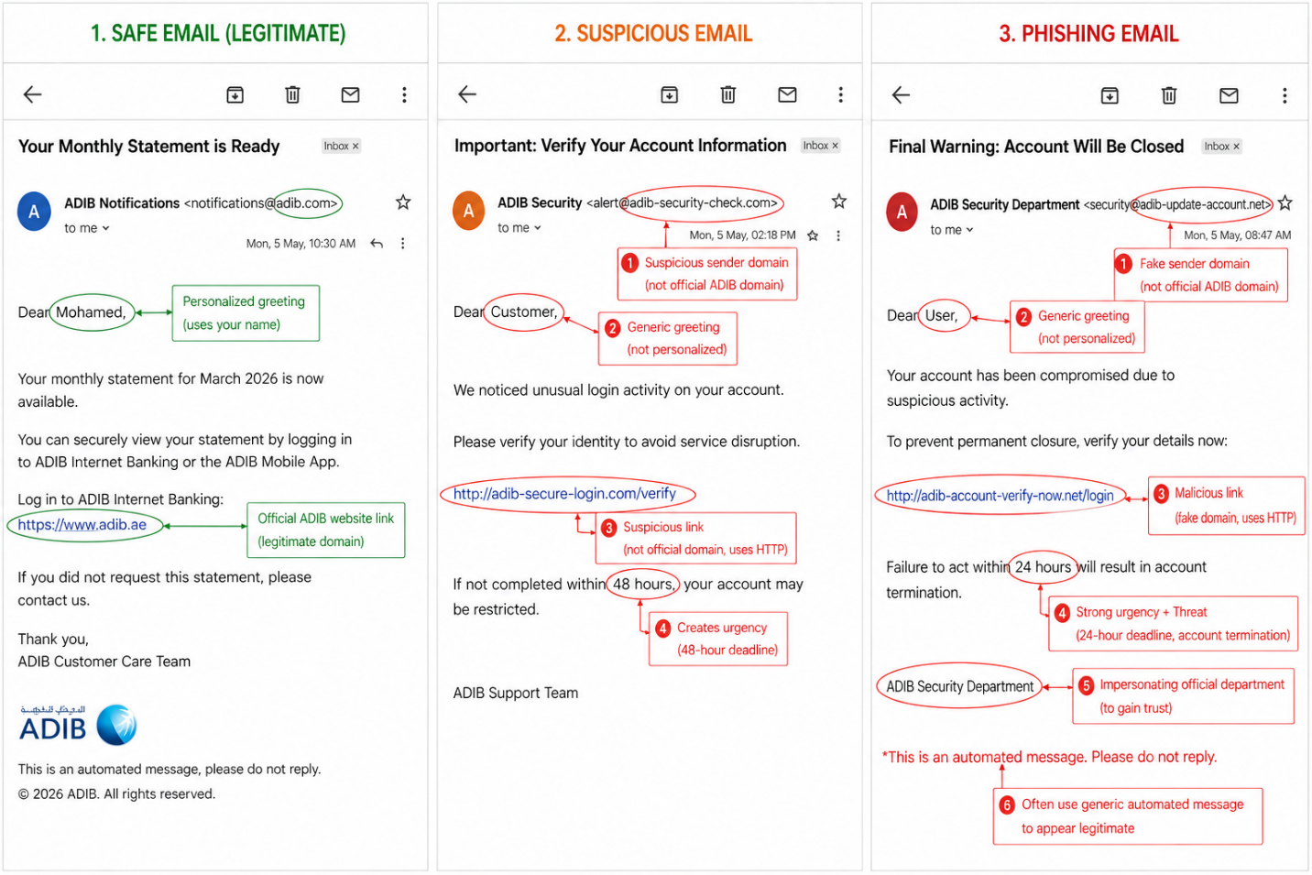
Figure 1: Legitimate Email from ADIB Bank
5.2 Email 2 – Suspicious Email
Subject: Important: Verify Your Account Information
Analysis:
This email contains warning signs and may be a phishing attempt.
Phishing Indicators:
- Suspicious sender domain (not official ADIB domain)
- Generic greeting (“Dear Customer”)
- Suspicious link (HTTP + fake domain)
- Creates urgency (48 hours)
Risk Classification: Suspicious

Figure 2: Suspicious Email with Potential Phishing Indicators
5.3 Email 3 – Phishing Email (High Risk)
Subject: Final Warning: Account Will Be Closed
Analysis:
This is a confirmed phishing email designed to steal credentials.
Phishing Indicators:
- Fake sender domain
- Generic greeting (“Dear User”)
- Malicious link (fake ADIB login page)
- Strong urgency (24 hours)
- Threat (account closure)
- Impersonation of security department
Risk Classification: Phishing (High Risk)

Figure 3: Phishing Email Using Social Engineering Tactics
6. Common Phishing Indicators
The following indicators were identified:
- Fake or suspicious sender domain
- Generic greetings (Dear User / Customer)
- Urgency and fear-based language
- Suspicious or shortened URLs
- Requests for sensitive information
- Impersonation of trusted organizations
7. How the Attack Works
Phishing attacks work by tricking users into trusting fake emails.
- Attackers send fake email
- User clicks malicious link
- Fake website opens (looks real)
- User enters credentials
- Attacker steals data
This is called social engineering because it targets human behavior.
8. Risk Classification Summary
Email Type | Risk Level | Description
Safe | Low | Legitimate communication
Suspicious | Medium | Needs verification
Phishing | High | Malicious attack

9. Prevention Guidelines
To avoid phishing attacks:
- Do not click unknown links
- Always check sender email address
- Use official websites/apps directly
- Never share passwords or OTPs
- Report suspicious emails immediately
10. Do’s and Don’ts
Do’s
- Verify sender identity
- Hover over links before clicking
- Use official banking apps
- Report suspicious emails
Don’ts
- Don’t panic due to urgency
- Don’t trust unknown links
- Don’t share sensitive information
- Don’t open unexpected attachments
11. Conclusion
Phishing attacks are highly effective because they exploit human trust rather than technical weaknesses. By understanding phishing indicators and following safe practices, users can significantly reduce the risk of cyberattacks. User awareness is the first line of defense against phishing attacks.

